COMP308 – Emerging Technologies

Final Team Project

Group #29



Table of Contents

Detailed description 3

The Team 3

Wireframes Section 3

Registration Page 3

Login Page 4

Generate Tournament Page 4

Tournament Bracket Page 5

Tournament History Page 5

Screen Capture Section 5

Potential Future Functionality 6

# **Detailed description**

Project Name: Tournament Fix

The project will be an open source Tournament Bracket and User Management System. Users will be able to create accounts which they can use to create tournament brackets.

To generate a tournament the user simply enters information regarding the tournament such as the Name, Type, Size and the Participants in the tournament and a Bracket is generated based on the information provided. As the tournament progresses, users can push up the players in the bracket who have successfully won a match. When a tournament has been completed, it is archived in the user’s tournament history page. Most of the navigation related to the site is done through the navbar which is always located at the top of the page.

Currently, the bracket generator will support standard bracket stage tournaments only.

# **The Team**

Benzir Ahmed: Project Manager

Adil Hussain: Developer and Designer

Nitin Rai: Developer

Kevin Luu: Developer

# **Wireframes Section**

## Registration Page

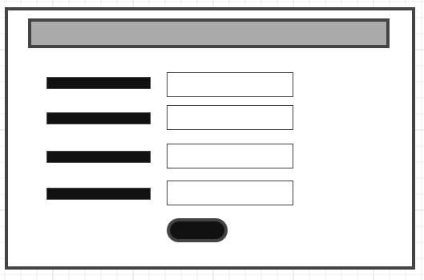

## Login Page

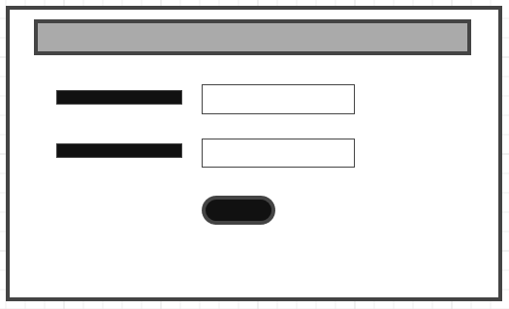

## Generate Tournament Page

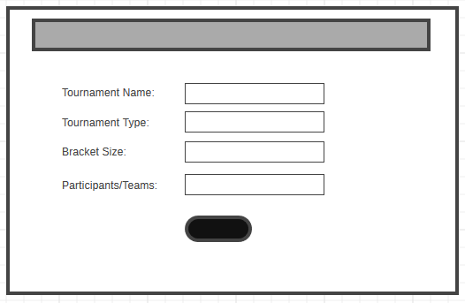

## Tournament Bracket Page

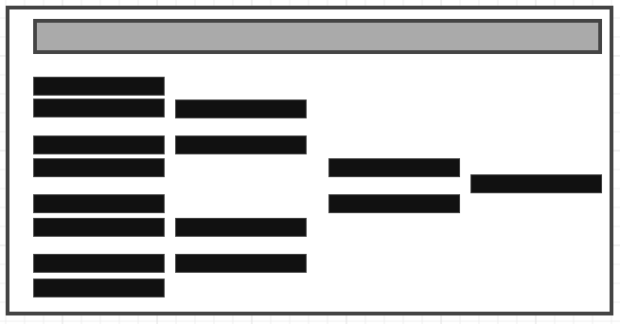

## Tournament History Page

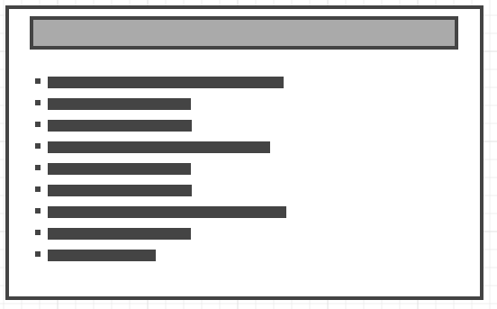

# **Screen Capture Section**

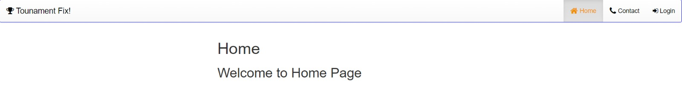

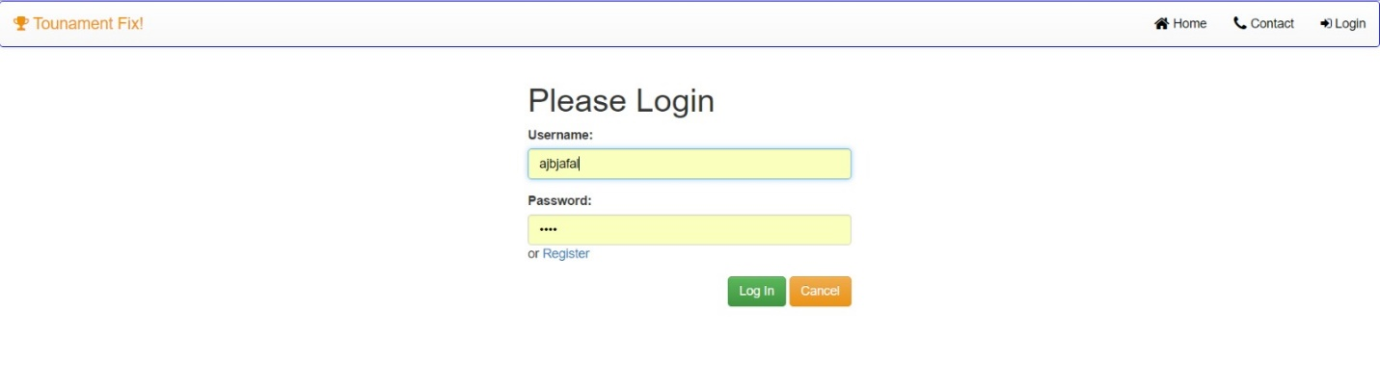

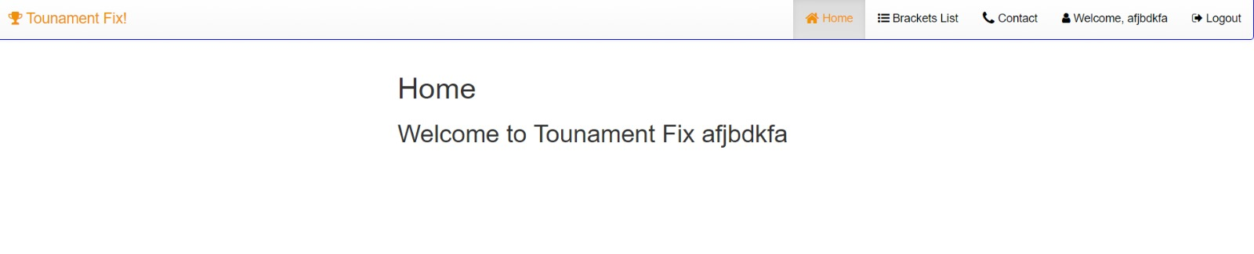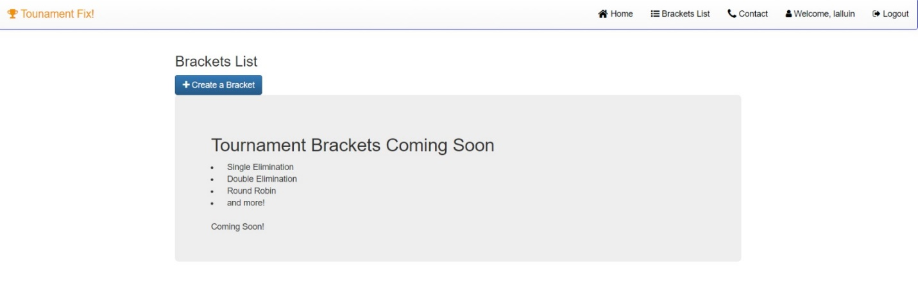

# **Potential Future Functionality**

* Double elimination: Lose once in the regular brackets, and then drop down to elimination brackets. Lose both series and you are out of the tournament eg.

